NAME: K Yamini
REG NO: 192572181

Write a Prolog Program to find the number of vowels.
Aim:
To implement a Prolog program to count the number of vowels in a given word.
Algorithm:
- Start the program.
- Define the input word as a list of characters.
- Check each character in the list.
- If the character is a vowel (a, e, i, o, u), increase the count.
- If the character is not a vowel, continue to the next character.
- Repeat until all characters are checked.
- Display the total number of vowels.
- Stop the program..
Prolog program:
% EXPERIMENT 32
% Find Number of Vowels

% Check whether a character is a vowel
vowel(a).
vowel(e).
vowel(i).
vowel(o).
vowel(u).

% Count vowels
count_vowels([], 0).

count_vowels([H|T], Count) :-
vowel(H),
count_vowels(T, C),
Count is C + 1.

count_vowels([H|T], Count) :-
\+ vowel(H),
count_vowels(T, Count).

% Main program
find_vowels :-
Word = [p,r,o,l,o,g],

write('Word: '),
write(Word),
nl,

count_vowels(Word, Count),

write('Number of vowels: '),
write(Count),
nl,
!.
Input:
In GNU Prolog, enter:
?- find_vowels.
You can also test directly:
?- count_vowels([p,r,o,l,o,g], Count).
Output :
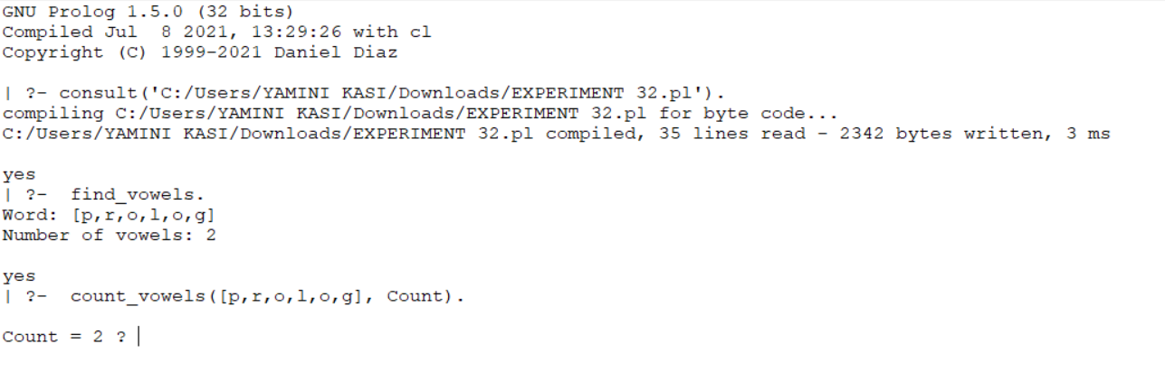
Result:
Thus, the Prolog program to find the number of vowels was successfully implemented and the number of vowels in the given word was obtained.

